Kennford International c/park (270)
Kennford International Caravan Park
Kennford
Exeter
EX6 7YN

17 June 2015
Our Ref: quot- 1705

Q U O T A T I O N

MAKE:
MODEL:
SERIAL NUMBER:
PITCH NUMBER: B1 Mrs Saunders
OWNER / SITE: Kennford International c/park (270)

Roof vent- £93.08 plus vat to supply only
Complete windup euro vent roof light assembly with removable fly screen self-venting ventilation rating 22000 SIZE; 14 x 14 x 4 deep liner (aperture dimension)
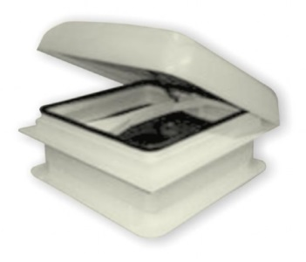

GB24 MORCO CONDENSING COMBI BOILER to supply only £763.84 plus vat
Product Description
Morco GB24, condensing LPG combination boiler with digital display, flue and fitting kit not included.

CRATING AND CARRIAGE £10.00 plus vat

Should Mrs Saunders Wish to place an order then please let me know.

Regards
Lorraine

I hereby authorise Surf Bay Leisure to carry out the repairs detailed in their quotation

SIGNATURE-----------------------------------------------------------------------

DATE --------------------------------------------------------------------------------

PLEASE SIGN AND RETURN AT YOUR EARLIEST CONVENIENCE

THANK YOU FOR YOUR CUSTOM

